**My Dream computer build**

**1.CPU**

I think i will choose Core i9-13K it is from the most powerful CPU

It is  **5.80 GHz ,** it is **24 cores and 32 threads**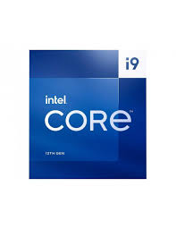

And it is Processor Power : **125 W**

And it can turbo boost it take power :**253 W**

And i think it is compatible for all uses

**2.Motherboard**

I think I will choose **GIGABYTE B760**  from my sight It is good.

And it supports 14th,13th,12th gen. Takes 4 ram slots.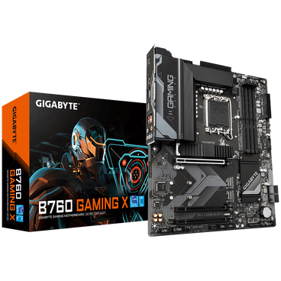

And 1*m.2 and 2*harddisk

**3.GPU**

I think i will choose **GIGABYTE RTX 4090** it is so **over kill**

And I chose it because it matches our CPU . It supports **Nvidia reflex**

And it supports **RAY Tracking.** It is so profissional in gaming and graphics and video editing like premiere.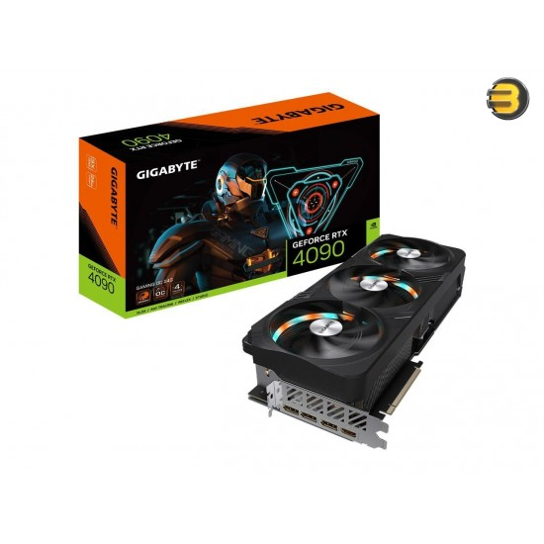

**4.case**

I will choose **ATX Mid Tower** it is a good case modern

It has a high air flow . And it includes two fans .and a good

Cable management . 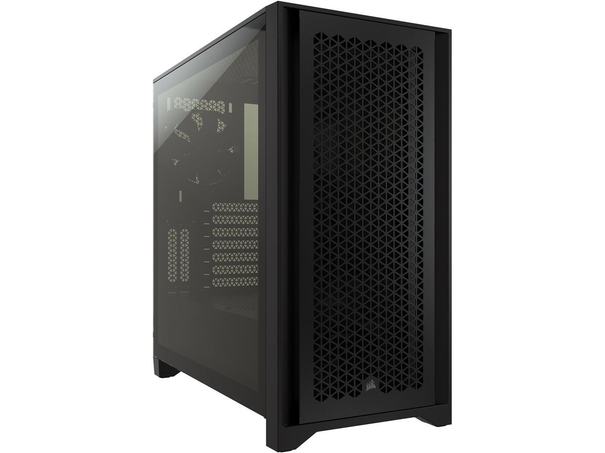

Resources:

**Cpu:**

<https://www.compumarts.com/ar/products/intel-core-i9-13900k-processor-36m-cache-up-to-5-80-ghz-bx8071513900k>

+++++++++++++++++++++++++++++++++++++++++++++++++++++++

**Gpu:**

<https://elbadrgroupeg.store/gigabyte-rtx-4090-gaming-oc-24gb-gddr6x-pci-express-4-0-x16-atx-video-card>

+++++++++++++++++++++++++++++++++++++++++++++++++++++++

**Case:** <https://www.newegg.com/black-corsair-4000d-airflow-atx-mid-tower/p/N82E16811139156>

+++++++++++++++++++++++++++++++++++++++++++++++++++++++

**Motherboard:**

<https://www.rayashop.com/en/gigabyte-b760-gaming-x-ddr4-intel-motherboard-5-b760-gaming-x-ddr5-arab>

+++++++++++++++++++++++++++++++++++++++++++++++++++++++

**{Thank you}**